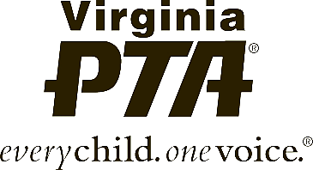
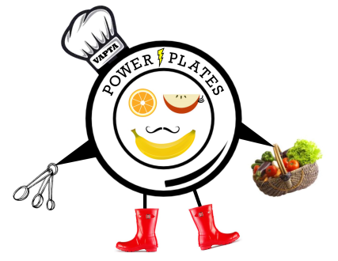
Virginia PTA
Power Plates Program
Official Rules
2016-2017

RULES FOR PARTICIPATION: By entering the “Virginia PTA Power Plates Program,” entrants accept and agree to be bound by these Official Rules as well as the entry requirements. Any violation of these rules may, at Virginia PTA’s discretion, result in disqualification. All decisions of the judges regarding this program are final and binding in all respects.

- Eligibility. Students must participate through a local PTA/PTSA in good standing according to Virginia PTA SOP. Parent groups not affiliated with National PTA or Virginia PTA are not eligible to sponsor this program. A student may develop an entry in or outside of school.

- Categories. There are five recipe categories – breakfast, lunch, snack, dinner entree or side dish, and dessert. Students may enter the program in one or more categories.

- Grade divisions. Students may enter in the appropriate division for their grade (Primary: Preschool – Grade 2; Intermediate: Grades 3-5; Middle School: Grades 6-8; High School: Grades 9-12; Special Chef: All grades). See Special Chef for entry requirements.

- How to enter. Entrants must submit their recipe, photo and entry form to Virginia PTA by email. Each entry should be emailed separately with the Students Name, Food Category and Division in the subject line of the e-mail. Entries should be e-mailed to PowerPlates@vapta.org by 11:59 p.m. on Friday, February 24, 2017.

- Entry requirements. Each entry must be the original work of one student only. An adult may not alter the creative integrity of a student’s recipe. Only one student may be recognized as the award recipient for each entry. Each entry must contain the following three items:

- A Virginia PTA Power Plates Program Student entry form with
- A title for the original recipe.
- A statement on what inspired the healthy recipe. Is it gluten-free, nut-free or lactose-free? What other healthy foods might be served with this recipe? It should be between one sentence and 100 words.
- A recipe typed on the provided entry form that is healthy according to the USDA nutrition guidance MyPlate at www.ChooseMyPlate.gov and contains
  - An ingredient list. This should be in standard U. S. measurement volume and weight. Ingredients should be commonly available at retail stores. Use generic names, not brand names.
  - Step-by-step preparation instructions, with cooking times, pan sizes, temperatures, and number of servings.
- A photograph under 2MB formatted as .jpg, .png or non-animated .gif. It should be a photograph of the food only. No person should appear in the photograph.

- Winner selection and notification. Judging will be based on the following criteria: 50% healthy nutritional value of the recipe; 25% perceived taste; 15% creativity and originality; 10% student statement. Awards will be announced by mail, email and/or telephone by April 7, 2017. Student finalists will be recognized at the Student Awards Ceremony on April 30, 2017.

- Ownership and license. Ownership in any submission shall remain the property of the entrant, but entry into this program constitutes entrant’s irrevocable permission and consent that Virginia PTA may display, copy, reproduce, enhance, print, sublicense, publish, distribute and create derivative works for PTA purposes. Virginia PTA is not responsible for lost or damaged entries. Submission of entry into the Virginia PTA Power Plates Program constitutes acceptance of all rules and conditions.

- Participating entities. This program is administered by the Virginia Parent Teacher Association (PTA) and PTA affiliates.

Virginia PTA
Power Plates Program
Official Entry Form
2016-2017

As part of our commitment to our children’s healthy eating habits, Virginia PTA is supporting a student recipe program to encourage students to create healthy meals. Deadline is 11:59 p.m. on Friday, February 24, 2017.

MEAL CATEGORY: ☐Breakfast ☐Lunch ☐Snack ☐Dinner entree/side dish ☐Dessert

GRADE DIVISION: ☐Primary ☐Intermediate ☐Middle School ☐High School ☐Special Chef
Pre-K-Grade 2 Grades 3-5 Grades 6-8 Grades 9-12 All Grades

TITLE OF RECIPE:Click here to enter text.

CHEF’S STATEMENT: (At least one sentence to 100 words.)

Click here to enter text.

Student’s Full Name | Click here to enter text. |  | Gender | Choose an item.
Student’s Grade | Choose an item. |  | Age | Click here to enter text.
Street Address | Click here to enter text.
City/County | Click here to enter text. |  | Zip |  | Click here to enter text.
Parent/Guardian Name(s): | Click here to enter text.
Parent/Guardian Phone | Click here to enter text. | E-mail | Click here to enter text.
Local PTA/PTSA | Click here to enter text. |  | City/County |  | Click here to enter text.

Ownership in any submission shall remain the property of the entrant, but entry into this program constitutes entrant’s irrevocable permission and consent that Virginia PTA may display, copy, reproduce, enhance, print, sublicense, publish, distribute and create derivative works for Virginia PTA purposes. Virginia PTA is not responsible for lost or damaged entries. Submission into the Virginia PTA Power Plates Program constitutes acceptance of all rules and conditions. By typing my name below, I understand the rules and regulations above.

Click here to enter text. |  | Click here to enter text.
Student Digital Signature |  | Parent/Guardian Digital Signature

Please send this entry form with the information below in an e-mail to PowerPlates@vapta.org. In the subject of the e-mail be sure to include the Student’s Name, Receipt Category and Division. One separate e-mail for each receipt entry.
- Recipe typed on the provided Recipe Form
- One (1) Photograph of prepared recipe in .jpg, .png, or non-animated .gif file format.

Virginia PTA
Power Plates Program
Recipe Form
2016-2017
INGREDIENTS:
- Click here to enter text.
- Click here to enter text.
- Click here to enter text.
- Click here to enter text.
- Click here to enter text.
- Click here to enter text.
- Click here to enter text.
- Click here to enter text.
- Click here to enter text.
- Click here to enter text.
- Click here to enter text.
- Click here to enter text.
- Click here to enter text.
- Click here to enter text.
- Click here to enter text.
- Click here to enter text.
- Click here to enter text.
- Click here to enter text.
- Click here to enter text.
- Click here to enter text.
- Click here to enter text.
- Click here to enter text.
- Click here to enter text.

RECIPE:
Click here to enter text.
Student’s Full Name | Click here to enter text. | Gender | Choose an item.
Student’s Grade | Choose an item. | Age | Click here to enter text.
Recipe Title | Click here to enter text.
Recipe Category | Choose an item.

